Memo 1/1/2021

In response to the comment from Jing’s email. “Furthermore, maybe we should calibrate both Amax and phi in each model to make similar average levels of BMAL (AT), and PER (P0+...+P) proteins”.

SNF 1M8, AT=0.1 and phi=1

Add an auxiliary variable Ptot = P0+P1+P2+P3+P4+P5+P

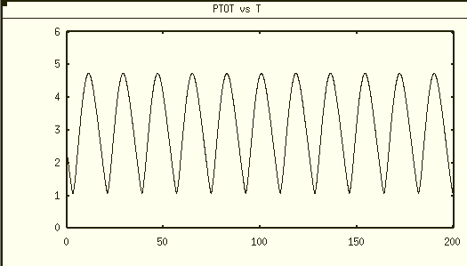

max Ptot ≈ 4.74, min Ptot ≈ 1.09, the average level of Ptot ≈2.92

NNF 1M8 Calibration of Amax with Vmax=5 (originally Vmax=1, from Dr. Tyson’s email, he suggested us to use Vmax=5)

1. calibrate for consistent average AT level

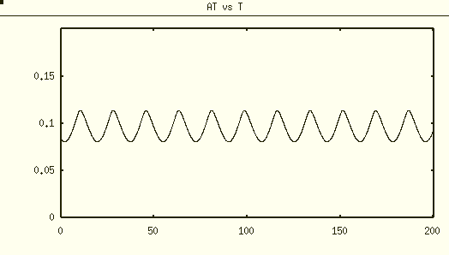

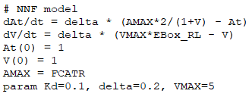



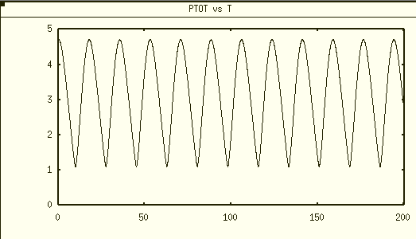

Ptot level is similar to SNF 1M8, with max≈4.71 and min≈1.11

PNF 1M8 calibration

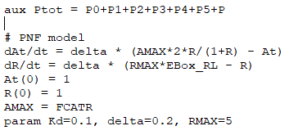



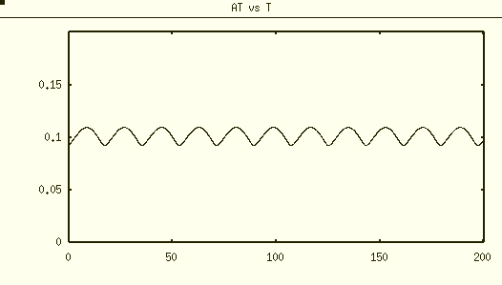

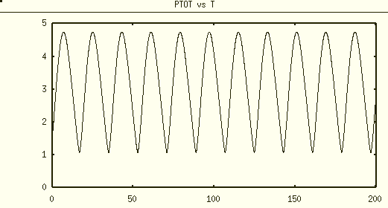

max≈ 4.74 min≈1.11

PNNF 1M8 calibration

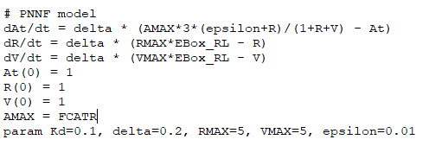



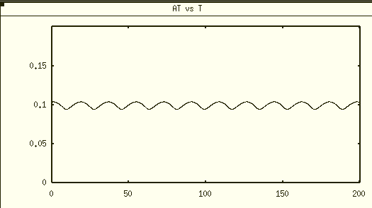

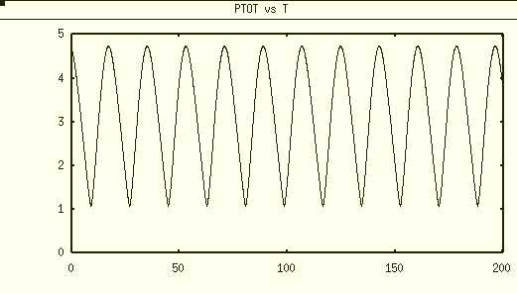

max≈ 4.73 min≈1.08

Sensitivity test of models to Amax

NNF 1M8 Amax = 0.2

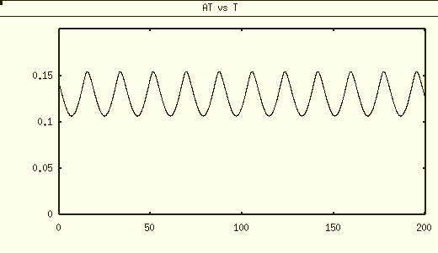

max ≈ 0.1546, min ≈ 0.1067

PNF 1M8 Amax=0.2

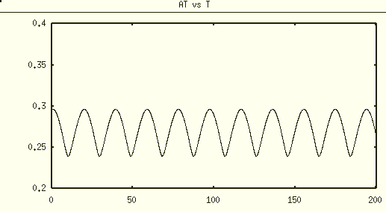

max ≈ 0.2961, min ≈ 0.2394

PNNF Amax=0.3

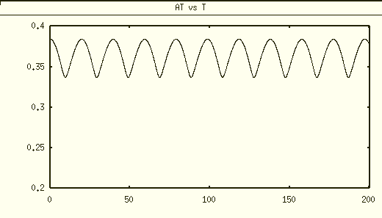

max ≈ 0.3842, min ≈ 0.3370